امیرحسین نجفی زاده 9831065 – تشریحی اول

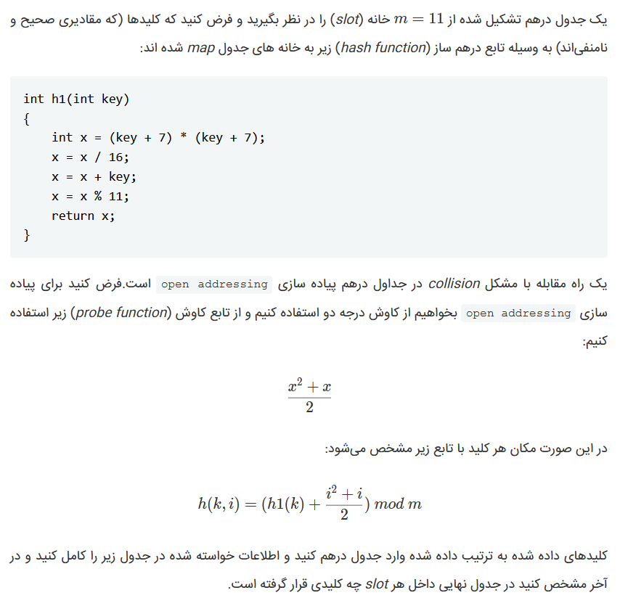

|  |  |  |
| --- | --- | --- |
| **Key** | **Home slot** | **Probe sequence** |
| 43 | 1 | 0 |
| 23 | 2 | 0 |
| 1 | 5 | 0 |
| 0 | 3 | 0 |
| 15 | 4 | 2 |
| 31 | 0 | 0 |
| 4 | 6 | 3 |
| 7 | 8 | 0 |
| 11 | 9 | 0 |
| 3 | 10 | 1 |

Final Hash-Map >> 31 | 43 | 23 | 0 | 15 | 1 | 4 | _ | 7 | 11 | 3